Improved Heuristics and a Genetic Algorithm for Finding Short Supersequences
J. Branke, M. Middendorf, and F. Schneider
OR-Spektrum, 20:39-46, 1998
Abstract
- Introduction
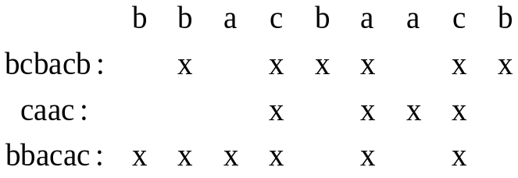
- TheHeuristics
For a character a_{i} of a string its weight w(a_{j}) is n-i.
- Heuristic H1(L):
H1 always choose that symbol of the front whose sum of the weight of all its occurrences in the front is maximal.
- Heuristic H2(L):
H2 always choose the symbol a from the front for which the following sum is maximized: the number of occurrences of a in the front plus the number of occurrences of the most frequent symbol in the new front that would emerge after removing the a’s from front.
- Heuristic H3(L):
For each symbol a in the front H3, computes the length of the super- sequences returned by H1 when applied to the string after removing a from the front. Then H3 chooses, as is most promising, that symbol to append to the supersquence for which the length returned by H1 is the smallest.
- The Genetic Algorithm
Created by: Ying-Jer Liao
Date: August 29, 2002

